**Toytastic**



**School of Business Administration**

SOFTWARE PROGRAM & PROJECT MANAGEMENT- Course Project Report

Submitted By :  Aswini Sivakumar

  Rana Hamdan

  Soundarya Bachu

Submitted To :  Dr. Ronald Papa

Date: 12/10/2023

# Table of Contents

Table of Contents 2

The Team Charter 4

**Team Name - Toytastic 4**

**Project Description (Vision) 4**

**Team Members 4**

**Skills and Knowledge Inventory 4**

**Agreed Upon Meeting Times and Location 5**

**A List of Team Rules and Expectations 5**

**Roles and Responsibilities 6**

**A Code of Ethics 6**

**Signatures 6**

**Project Scope Statement 7**

**Business Case 7**

**Project Objective 8**

**Key Deliverables 8**

**Milestones 9**

**Technical requirements 10**

**Limits and Exclusions 10**

**Risks 11**

**Customer Review 11**

**Critical Success Factors 11**

**Work Breakdown Structure 12**

**Coded Work Breakdown Structure 12**

Project Network Diagram 15

**Cost Analysis 16**

**Risk Analysis 18**

**Project Risks 18**

**Project Kickoff 20**

**Planning Decisions 20**

**Tracking Decisions 21**

**Managing change Decisions 21**

**Relationship Decisions 21**

**Project Plan / Schedule 22**

**Gantt chart 22**

**Project Management Methodology Summary 22**

**Project Closure 23**

**Retrospective and Lessons Learned 24**

# The Team Charter

### **Team Name** - Toytastic

### **Project Description (Vision)**

To develop a mobile application - Toytastic, that revolutionizes the way children and families share toys and games. The primary objective of this project is to create a user-friendly, secure, and efficient platform that connects parents and caregivers, allowing them to share toys and games among their children's peer groups. The app will target iOS and Android platforms, ensuring accessibility for a wide user base. The Toy Share app aims to make toy-sharing a convenient and sustainable option for parents, while also promoting social interactions and reducing the environmental impact of toy production and waste. As we move forward with this project, our team is committed to creating a robust, user-friendly, and secure app that fulfills our mission of making playtime more enjoyable, affordable, and eco-friendly for families in the US.

The project is estimated to take 15 months, starting from project initiation to the official launch of the app in app stores. This timeline includes requirements gathering, design, development, testing, and the launch phase.

Location: United States of America

### **Team Members**

| **Team Members** | **Email ID** | **Contact #** |
| --- | --- | --- |
| Rana Hamdan | [ranahamdan@oakland.edu](mailto:ranahamdan@oakland.edu) | (***)-***-8851 |
| Aswini Sivakumar | [aswinisivakumar@oakland.edu](mailto:aswinisivakumar@oakland.edu) | (***)-***-7395 |
| Soundarya Bachu | [soundaryabachu@oakland.edu](mailto:soundaryabachu@oakland.edu) | (***)-***-2558 |

### **Skills and Knowledge Inventory**

**Rana Hamdan:** Rana brings a wealth of skills and knowledge to our team, particularly in the realm of Agile development practices. She excels at fostering adaptable project workflows, ensuring that our team remains agile and responsive to changing project needs. Her communication skills are a strong asset, allowing her to effectively convey complex technical concepts and provide regular project updates. Her decision-making abilities are marked by data-driven recommendations, which are instrumental in guiding our project decisions. She is well-versed in object-oriented system analysis and design techniques and proficiently uses modeling tools like ERD and UML to document data and process requirements. Additionally, her expertise extends to the vital aspects of user interface design. In the realm of data modeling and database design, this team member is well-equipped. She possesses comprehensive knowledge of SQL, data warehousing, and data mining concepts.

**Aswini Sivakumar:** Aswini brings over 5 years of professional experience in the retail and banking industries. She possesses a thorough understanding of how an Agile project operates. Her analytical thinking and problem-solving abilities serve as a strong driving force to complete projects on time and within budget. Proficient in SQL, data mining and data warehousing concepts, she is experienced in setting up and maintaining data warehouses. Additionally, she excels in creating wireframes and UI designs. She adeptly leverages visualization tools such as SSRS, Power BI, and Tableau to generate insightful reports and dashboards.

**Soundarya Bachu:** Soundarya is an IT Professional with 5 Years of working knowledge on database and management systems with cross functional knowledge. She is good in handling the life cycle of the Data, Great in Data Validation, Reconciliation, Understanding, Discovering insights and Performance tuning, Optimization, Data integrity and Statistics. She is experienced in MSBI (SQL, SSIS, SSRS), Snowflake, Matillion and Netezza. Have knowledge on ADF, Azure SQL, Python and Power BI. She is very good at analyzing the problems, working a way towards finding and proposing different solutions to the problems. She is a team player with Good analytical, Communication and Organization Skills and outstanding time management.

### **Agreed Upon Meeting Times and Location**

We have mutually agreed upon the following designated meeting slots:

Tuesday, from 12:00 PM to 1:00 PM, to be conducted via Zoom

Friday, from 12:00 PM to 1:00 PM, also to be held via Zoom

These established time slots and digital meetings are set to facilitate our professional engagements and discussions.

### **A List of Team Rules and Expectations**

* All team members are expected to attend every scheduled meeting on time. If there is a conflict, you’re expected to notify the team as soon as possible.
* Communicate openly and honestly.
* Every team member should contribute equally to the project.
* Every team member should contribute high-quality work, and also review the work of other members for accuracy
* Regularly update each other on progress and challenges related to our roles
* Every team member will adhere to agreed-upon deadlines and milestones and inform the team immediately if we anticipate any delays.
* Will address conflicts or disagreements promptly and respectfully, and then seek solutions that benefit the project and the team as a whole.

### **Roles and Responsibilities**

**Rana Hamdan - Project Manager and Marketing Specialist**

* The Project Manager oversees the entire app development process, from planning to execution.
* They are responsible for setting project goals, timelines, and ensuring that the team stays on track.
* This role involves coordinating the efforts of the team members, monitoring progress, and managing any potential issues or roadblocks that may arise.

**Soundarya Bachu - App Developer/Software Engineer**

* App Developers or Software Engineers are responsible for coding and programming the app.
* They turn the design and functionality concepts into a functional app.
* This role includes front-end and back-end development, ensuring that the app works smoothly and is bug-free.

**Aswini Sivakumar - User Experience (UX) Designer**

* The UX Designer is responsible for creating an intuitive and visually appealing user interface.
* They design the app's layout, ensuring it's user-friendly and responsive.
* This role focuses on understanding user behavior, conducting user research, and creating wireframes and prototypes to optimize the user's experience with the app.

### **A Code of Ethics**

We, Team Toytastic, will uphold integrity, accountability, and professionalism. Our top priority is our client's satisfaction, and we will achieve this through quality, innovation, and open communication.

### **Signatures**

Rana Hamdan 10/12/2023

Aswini Sivakumar 10/12/2023

Soundarya Bachu 10/12/2023

# **Project Scope Statement**

### **Business Case**

Toytastic is a forward-thinking organization based in the United States of America, dedicated to transforming the way children and families share toys and games. Our mission is to make playtime more enjoyable, affordable, and eco-friendly by developing a cutting-edge mobile application, which connects parents and caregivers, enabling them to share toys and games within their children's peer groups.

Toytastic is embarking on an exciting project to develop a mobile application designed to revolutionize toy-sharing practices within communities. This innovative app will be available on both iOS and Android platforms, ensuring accessibility to a wide user base.

Toytastic project is driven by a diverse set of factors that underpin its necessity. Firstly, it addresses the challenge faced by modern families in keeping their children engaged with a constant stream of new toys in today's fast-paced world. Toytastic, as a solution, opens up a world of opportunities for children by making a wide range of toys accessible, fostering learning and enjoyment.

Additionally, Toytastic contributes to the promotion of social interactions among children. Beyond alleviating the financial burden on parents, it cultivates a sense of community, cooperation, and empathy—essential life skills in today's society.

Moreover, the project's focus on environmental sustainability is crucial. The Toytastic app directly tackles the pressing issue of excessive toy production and waste. By facilitating toy-sharing, it aligns with global efforts to encourage eco-conscious living and consumption, reducing the environmental footprint associated with the toy industry.

Recognizing the challenges parents face in terms of time, space, and budget constraints, Toytastic offers a user-friendly and cost-effective solution. It aims to make playtime more enjoyable for children while alleviating the financial burden on parents and caregivers.

The Toytastic project spans an estimated 15-month timeline, encompassing essential phases like requirements gathering, design, development, rigorous testing, and the highly anticipated launch phase. This comprehensive approach ensures that the project proceeds smoothly from initiation to the official app launch in various app stores.

The app would Offer a monthly or yearly subscription plan for users. Subscribers could enjoy premium features, such as priority access to popular toys, advanced sharing options, and exclusive discounts on toy purchases.

Toytastic is fully committed to this groundbreaking initiative, which embodies our core values of innovation, sustainability, and community-building. We firmly believe that Toytastic will empower families to create a brighter future for their children, emphasizing the significance of shared experiences, environmental responsibility, and financial stability.

We invite you to join us on this remarkable journey to transform playtime into an enjoyable, affordable, and eco-friendly endeavor for families around the world. Together, we can collectively contribute to making the world of toys more Toytastic than ever before.

### **Project Objective**

The Toytastic app is a revolutionary tool that transforms how families share toys and games, making playtime more enjoyable, eco-friendly, and affordable. It will be launched on both iOS and Android platforms, accessible to a wide user base in the US. The project is estimated to take 15 months from initiation to the official app store launch, starting from December 2023.We anticipate a budget of $500,000, which we aim to optimize for cost-effectiveness. Toytastic 's primary goal is to provide a user-friendly, cost-effective, and sustainable solution for families worldwide, fostering accessibility, social interactions, and regulated space for families to share and exchange toys, promoting both financial savings and eco-consciousness while nurturing a sense of community and fun among its users.Users can list their pre-owned toys for sale by paying a nominal fee., allowing others to purchase them. Buyers, however, won't incur any charges; only the sellers will be subject to fees.

### **Key Deliverables**

1. System requirements
2. Data Collection
3. ERD modeling
4. Wireframes
5. System Design
6. User-interface (UI) and User-experience (UX) design for the app
7. Software coding/Implementation
8. Database to store user profiles, toy listings and transactions
9. Test the app on various app stores.
10. Prototype
11. Test all the features (User Registration, toy listing, search, filter, schedule, book, message, pay (including PayPal, ApplePay, CreditCards), upload photos, review, and rating)
12. Quality Assurance and Feedback
13. User manual
14. Approved App launch
15. Maintenance and updates
16. Customer Support

### **Milestones**

| **Initiation Phase** | |
| --- | --- |
| Complete Gathering Requirements | 12/28/2023 |
| Obtain necessary approvals | 1/11/2024 |
| **Planning Phase** | |
| Developed work breakdown structure completed | 1/31/2024 |
| Complete Technical requirements analysis | 1/31/2024 |
| Project kickoff | 2/5/2024 |
| **Design Phase** | |
| Complete Wireframes and Mock-ups | 3/18/2024 |
| Complete UX/UI Design | 4/22/2024 |
| **Execution phase** | |
| Complete Prototype Testing and Feedback | 6/7/2024 |
| Complete iteration 1 Development and testing | 7/29/2024 |
| Complete iteration 2 Development and testing | 9/9/2024 |
| Complete iteration 3 Development and testing | 10/21/2024 |
| Complete QA and User acceptance Testing | 11/8/2024 |
| Complete Application Deployment and soft Launch | 12/6/2024 |
| Complete full app launch | 1/16/2025 |
| **Closure Phase** | |
| Project completion | 2/20/2025 |

### **Technical requirements**

* The system shall utilize an easy-to-use interface for the users.
* The system shall have an average of 99.99% availability.
* The system shall create a continuous backup mechanism.
* The system shall have a server running 24/7.
* The system shall have a recovery time averaging below 3 hours.
* The system shall respond to users within <=0.5 seconds.
* The system shall use multi-factor Authentication.
* The system shall use the AWS fully managed Relational Database to host the database on cloud.
* The system shall secure a sensitive data stream by encryption using approved encryption algorithms.
* The system shall generate logs for important security events.
* The system shall implement a secure output validation framework.
* The system shall use React Native framework for both Android and iOS.
* The system must report immediate errors to the admins and users.
* The system must automatically update from the support server.

### **Limits and Exclusions**

* The app will be offered exclusively in American English.
* The app can handle up to 15,000 users at a time
* App Users are responsible for the photos they upload.
* The initial scope of the app is limited to the United States only, with consideration for expansion to other countries in the future.
* Third-party integrations with payment gateways are restricted to PayPal, AMEX, Visa, and Mastercard.
* All transactions are limited to USD only.
* App users are responsible for content creation.
* The scope of the app is limited to messaging between users for toy requests and coordination and does not include features like group chats or forums.
* After only 25 transactions per user, the app will provide personalized recommendations based on their preference and sharing trend.

### **Risks**

* User Privacy and Security: Ensuring the security of user data and privacy is critical, and any data breaches could harm the application's reputation.
* User Adoption: There's a risk that the target audience might not adopt the platform as expected, impacting user growth and engagement.
* User Trust: Building and maintaining user trust is crucial. Negative user experiences or disputes among users could erode trust in the platform.
* Supply and Demand Balancing: Balancing the number of users who want to share toys with those who want to borrow toys can be a challenge, leading to potential imbalances in the system.
* Scalability: As the user base grows, scalability issues may arise in terms of server capacity, database management, and system performance.
* Technological Challenges: Technical issues, such as application crashes, slow loading times, or integration problems, could disrupt the user experience.
* Funding and Financial Sustainability: Securing funding for the project and ensuring long-term financial sustainability can be a risk, particularly if the application takes time to monetize.
* Resource Constraints: Team availability, budget limitations, and technology constraints may affect project execution.
* External Factors: External events like economic downturns, natural disasters, or global crises can impact project timelines and resources.
* Operational Challenges: Ensuring the smooth day-to-day operation of the platform, including customer support and dispute resolution, is essential and may present challenges.

### **Customer Review**

Approved by Project Owner: Jessica Smith

Jessica smith 11/10/2023

### **Critical Success Factors**

* Achieve a user adoption rate of at least 30% of the target audience within the first six months after launch, signifying successful market penetration.
* Maintain a steady and growing base of Monthly Active Users, with the goal of increasing MAU by 10% every quarter after the app's first year in operation.
* Achieve a 12-month user retention rate of at least 60%, indicating that users find value in the app and continue to engage with it.
* Ensure the app's toy database contains a minimum of 5,000 unique toy entries within the first year, enhancing the app's appeal and utility.
* Measure a 20% reduction in the environmental impact associated with toy production and waste compared to pre-app usage levels within two years.
* Attain a subscription conversion rate of 10% or higher among free users, demonstrating a successful monetization strategy.
* Ensure Resolution time for disputes is handled within 24 hours.
* Return on Investment (ROI) for marketing efforts need to be a positive number.
* Turnaround time for bug fixes:
  + Critical Bugs: Bugs that cause system crashes or data corruption should be addressed immediately, often within hours.
  + Major Bugs: Bugs that significantly impact functionality but do not cause a system failure should be fixed in a short timeframe, typically within 2-3 days.
  + Minor Bugs: Less critical issues, such as cosmetic problems or minor functionality glitches, may have a longer turnaround time, but they should still be addressed in a reasonable time frame, 10+ days.

# **Work Breakdown Structure**

### **Coded Work Breakdown Structure**

| WBS | Task Name |
| --- | --- |
| **1** | **Initiation Phase:** |
| 1.1 | Define project scope, goals, and objectives |
| 1.2 | Gathering Requirements |
| 1.3 | Develop a business model and revenue strategy |
| 1.4 | Obtain necessary approvals |
| **2** | **Planning Phase:** |
| 2.1 | Develop work breakdown structure |
| 2.2 | Risk analysis |
| 2.3 | Cost analysis |
| 2.4 | Technical requirements analysis |
| 2.5 | Project plan & schedule finalized |
| 2.6 | Project kickoff |
| **3** | **Design Phase** |
| 3.1 | Define application architecture |
| 3.2 | Wireframes and Mock-ups Creation |
| 3.3 | UX/UI Design |
| **4** | **Prototype Development** |
| 4.1 | Prototype Creation |
| 4.2 | Prototype Testing and Feedback |
| **5** | **Application Development** |
| 5.1 | Database Creation |
| **5.2** | **Full-scale Development** |
| 5.2.1 | Iteration 1 Development and testing |
| 5.2.2 | Iteration 2 Development and testing |
| 5.2.3 | Iteration 3 Development and testing |
| 5.2.4 | Payment Gateways integration testing |
| 5.3 | QA and UA Testing and Bug Fixing |
| **6** | **Deployment** |
| 6.1 | Soft Launch |
| 6.2 | Feedback Collection and Adjustments |
| 6.3 | Full App Launch |
| **7** | **Closure Phase** |
| 7.1 | Performance Monitoring |
| 7.2 | Evaluation against Goals and Objectives |
| 7.3 | Future Enhancements Planning |
| 7.4 | Project Shutdown |
| 7.5 | Lessons learned |
| 7.6 | Project close-out checklist |
| 7.7 | Project completion |

# Project Network Diagram

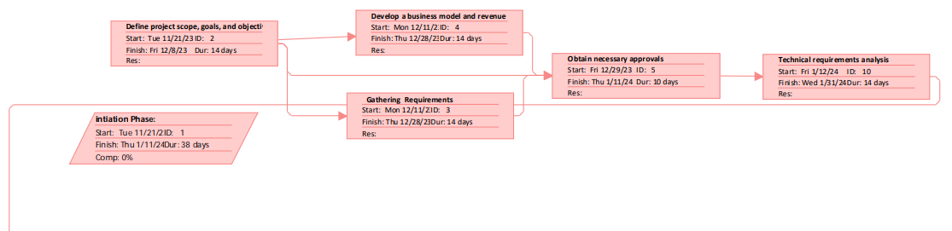

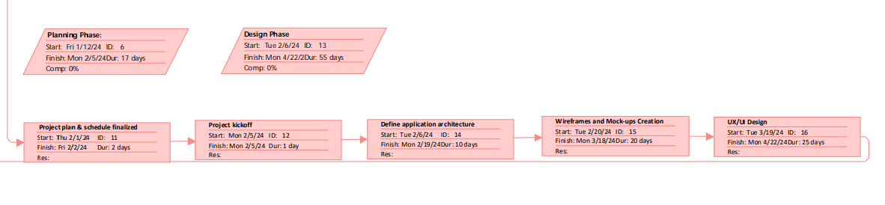

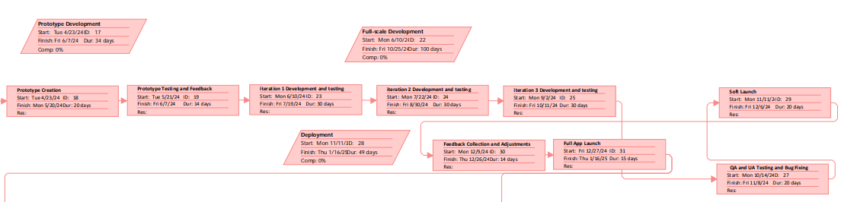

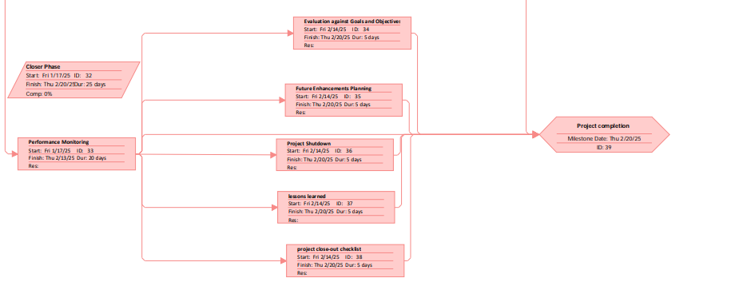

# **Cost Analysis**

The overall cost breakdown is estimated by considering direct costs, such as procuring hardware, software, and servers for the project, as well as direct overhead costs, including the salaries of the three project team members and the cost of renting office space for one year, as shown below.

| **Cost Breakdown** | |
| --- | --- |
| Procuring software | $ 25,000 |
| Procuring Hardware | $ 10,000 |
| Obtaining server for hosting the app | $ 10,000 |
| Database setup and maintenance | $ 5,000 |
| Digital Marketing and advertising Expenses | $ 5,000 |
| Salary for 3 project members for 1 year | $ 225,000 |
| Rental Office space for 1 year | $ 12,000 |
| Customer support expenses | $ 5,000 |
| **Total Cost outflow** | **$ 297,000** |

The yearly maintenance costs are calculated for each year from the beginning of year 1 to year 5, as shown below. As our app operates as a small business, the app store collects a 15% commission fee on the overall revenue for the year. The calculations below also account for the minimal impact of inflation.

The project's revenue comes from monthly subscriptions paid by users and a transaction fee for a successful toy exchange, approximately 5% of the transaction value. Toytastic app begins with approximately 5,000 users in year 1 and steadily increases, thereby boosting the revenue stream over the years. The calculations below also take into account inflation by increasing the average transaction value by a certain percentage.

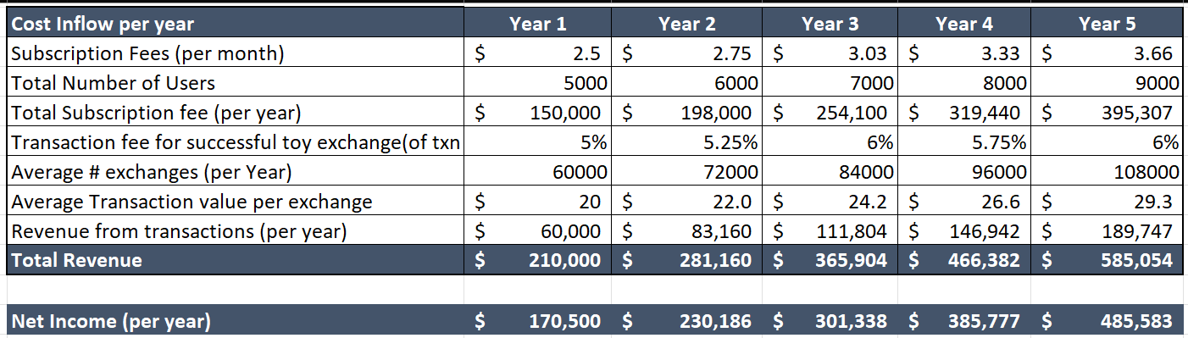

Based on the aforementioned cost-revenue model and applying a required discount rate of 10%, it is evident from the table below that the Net Present Value (NPV) for the project is projected to be $839,636.36. This positive NPV indicates that our app is expected to generate more cash flow over the upcoming 5-year timeline than its maintenance and the initial investment made in it.

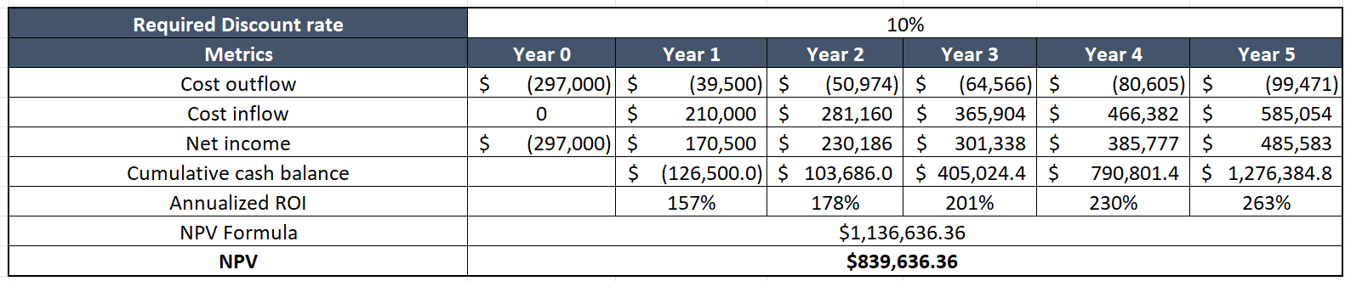

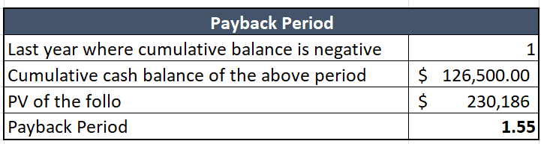

A closer look at the cumulative cash balance for the first 5 years reveals that the benefits from the app outweigh its costs. Additionally, the payback period is 1.55 years, signaling a quick turnaround to recoup the initial investment, after which the app enters a safe zone in terms of cash flows. The annualized ROI is quite high, starting from year 1 and increasing steadily. This trend is a positive indicator that, barring significant external risks, the project is highly likely to succeed. Overall, it is a worthwhile investment, and the project is deemed feasible.

# **Risk Analysis**

### **Project Risks**

1. Technical Risks - Scalability Problems: The application may struggle to handle increased user traffic or toy inventory growth without performance issues.
2. External Risks - Economic Instability: Unexpected economic downturn impacting project funding or user spending on toys.
3. Organizational Risks -Team Attrition: Key team members leaving the project, causing knowledge gaps and delays in project continuity.
4. Organizational Risks -Lack of Stakeholder Support: Insufficient backing or involvement from key stakeholders affecting decision-making and project progression.
5. Project Management Risks - Inadequate Project Planning: Poorly defined project scope, milestones, or resource allocation leading to project delays or budget overrun.
6. Project Management Risks - Dependency on External Dependencies: Reliance on external factors (APIs, libraries) that are not within the team's control may cause delays.
7. Customer Risks - Changing User Requirements: Evolving user preferences or market trends affecting the project's alignment with user needs.
8. Customer Risks - Low User Engagement: Insufficient user interest or engagement due to ineffective marketing or user interface design.
9. Other Risks - Legal/Compliance Issues: Legal challenges related to copyright, privacy, or regulatory compliance impacting project timelines.
10. Technology Obsolescence: Rapid changes in technology rendering chosen frameworks or tools obsolete during development.

**Risk Assessment Form**

| **Risk Assessment Form** | | | | |
| --- | --- | --- | --- | --- |
| **Risk ID** | **Risk Description** | **Likelihood (1-5)** | **Impact (1-5)** | **Total (L x I)** |
| 1 | Scalability Problems | 4 | 4 | 16 |
| 2 | Economic Instability | 2 | 3 | 6 |
| 3 | Team Attrition | 2 | 4 | 8 |
| 4 | Lack of Stakeholder Support | 3 | 3 | 9 |
| 5 | Inadequate Project Planning | 4 | 4 | 16 |
| 6 | Dependency on External Dependencies | 3 | 3 | 9 |
| 7 | Changing User Requirements | 3 | 4 | 12 |
| 8 | Low User Engagement | 3 | 3 | 9 |
| 9 | Legal/Compliance Issues | 2 | 4 | 8 |
| 10 | Technology Obsolescence | 4 | 3 | 12 |

**Risk Response Matrix**

| **Risk Response Matrix** | | |
| --- | --- | --- |
| **Risk ID** | **Risk Description** | **Response Strategy** |
| 1 | Scalability Problems | Implement load testing and scalable architecture |
| 2 | Economic Instability | Diversify funding sources and financial planning |
| 3 | Team Attrition | Cross-train team members and document processes |
| 4 | Lack of Stakeholder Support | Engage stakeholders early and ensure regular updates |
| 5 | Inadequate Project Planning | Review and update project plan regularly |
| 6 | Dependency on External Dependencies | Have contingency plans and alternative options |
| 7 | Changing User Requirements | Implement agile development and iterative updates |
| 8 | Low User Engagement | Enhance marketing strategies and UX/UI improvements |
| 9 | Legal/Compliance Issues | Regular legal reviews and compliance monitoring |
| 10 | Technology Obsolescence | Continuous technology evaluation and updates |

**Risk Management Summary**

We identified a diverse range of risks across technical, external, organizational, project management, and customer aspects of the toy static application development. By assessing likelihood and impact, appropriate response strategies have been defined to mitigate or manage these risks effectively. Proactive planning, continuous monitoring, and adaptability will be key to navigating these potential challenges during the project lifecycle.

# **Project Kickoff**

The initial project kickoff meeting will take place during the planning phase, following the initial preparation for the project, such as defining scope, goals, and objectives. The key participants in this meeting will be the team, consisting of a UX designer, app developer, and the project manager. The agenda for the meeting will briefly cover the following items:

1. Introduction of team members.
2. Review of the project scope and objectives to ensure a shared understanding among all team members.
3. Detailed review of the project plan.
4. Assignment of work packages to establish the roles and responsibilities of each team member.
5. Establishment of clear operational ground rules governing how participants should collaborate as a team.
6. Emphasis on meeting times, locations, code of ethics, team rules, and expectations previously agreed upon by team members during the drafting of the team charter.

To provide a preview of the upcoming meetings, this session should establish a clear understanding of how to address any procedural or organizational issues that might arise during the project's lifespan. The aspects mentioned below will help us gain clarity on that.

### **Planning Decisions**

The project plan, incorporating the Work Breakdown Structure (WBS) and Gantt chart, will be created using Microsoft Project. The project manager is responsible for implementing any changes to the project plan and communicating these adjustments to team members and stakeholders. Work package deliverables will be approved and signed off by the product owner. Due to the time-sensitive nature of this project, it is imperative that we promptly schedule an additional meeting to discuss an alternative plan in the event of a schedule slip in the critical path.

### **Tracking Decisions**

The app development team will follow agile processes, conducting daily standup meetings from 9:00 AM to 9:30 AM. In these meetings, team members discuss tasks accomplished the previous day, the tasks they will be working on that day, and any issues encountered the previous day, along with their resolutions. The scrum master will facilitate these meetings. Sprint meetings will be held bi-weekly, during which product owners and other key stakeholders are updated on the project’s progress. The scrum master will compile meeting notes and share them with participants via email. The project manager is responsible for generating and distributing reports.

### **Managing change Decisions**

Any changes to the project scope, plan, or deliverables will be addressed in a meeting with all team members and key stakeholders. The Project Manager is responsible for evaluating the anticipated trade-offs caused by the proposed change while ensuring client satisfaction. This meeting should encompass discussions about the cost, schedule, and quality impact the change would have on the project, as well as how the team plans to manage the trade-offs. The changes must be signed off by the product owner and carefully documented in the change management system.

### **Relationship Decisions**

The team will interact with the marketing team and key stakeholders throughout the project lifecycle. Team members should utilize Microsoft Teams and the organization’s email system for all project-related communications. Upon completion of a feature for a particular sprint, it must undergo review by a peer team member and approval by the project manager. Regular progress updates about project activities will be logged in JIRA and made accessible to all project stakeholders. This provides stakeholders with visibility into the current status of the project. Lower-granularity details, such as code functionality, should not be shared on public platforms like Stack Overflow or Reddit.

# **Project Plan / Schedule**

### **Gantt chart**

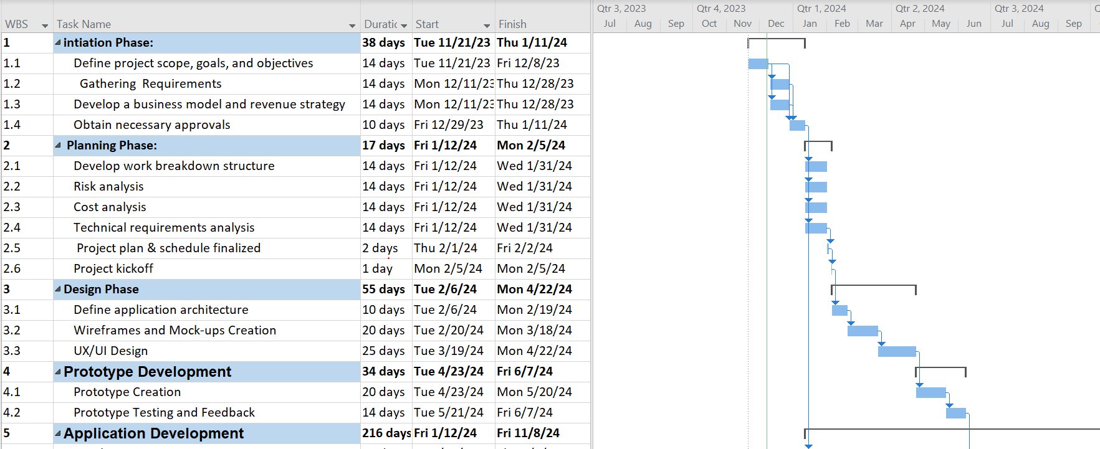

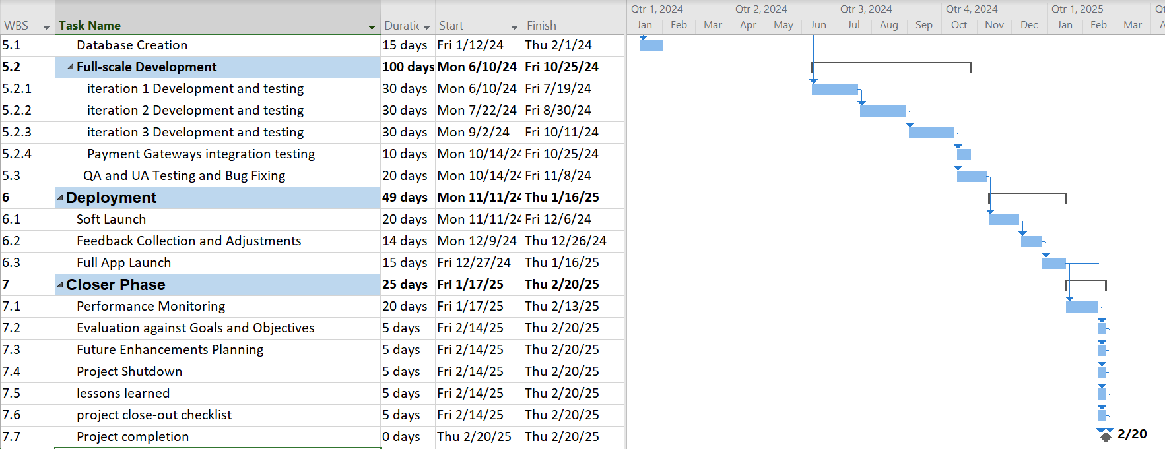

# **Project Management Methodology Summary**

The chosen methodology for our project implementation was a hybrid approach, stemming from our prior experiences with the agile methodology and a desire to explore more. Having successfully executed projects using agile methodologies in the past, we acknowledged their inherent strengths in promoting collaboration, adaptability, and iterative development. However, recognizing the potential limitations of a strictly agile framework, we aimed to integrate elements from both agile and traditional methodologies to form a hybrid model.

The decision to opt for a hybrid methodology was driven by a quest for balance—leveraging the iterative nature of agile while incorporating structured phases and documentation typical of traditional project management. This hybrid model allowed us to capitalize on agile's responsiveness to change while ensuring a clearer delineation of project stages, enhancing predictability and risk management. Moreover, the hybrid approach fostered a more inclusive environment, enabling the team to maintain a dynamic workflow while adhering to predefined milestones and deliverables, thereby maximizing efficiency and adaptability throughout the project lifecycle.

# **Project Closure**

| **Task** | **Completed? Yes/No** |
| --- | --- |
| **Team** | |
| 1. Develop and accept schedule for reducing project staff | Yes |
| 2. Release or notify staff of new assignments | Yes |
| 3. Conduct performance reviews for team members | Yes |
| 4. Offer staff outplacement services and career counseling | Yes |
| **activities** |  |
| 5. Organize a knowledge transfer session for departing staff | Yes |
| 6. Archive project documentation and materials | Yes |
| 7. Conduct exit interviews with departing team members | Yes |
| **Vendors/Contractors** | |
| 8. Conduct performance reviews for all vendors | Yes |
| 9. Settle outstanding payments and close contracts | Yes |
| 10. Obtain feedback from vendors on project collaboration | Yes |
| **Customer/Users** | |
| 11. Obtain customer sign-off on the delivered product | Yes |
| 12. Conduct a post-project survey for customer feedback | Yes |
| 13. Schedule a lessons-learned meeting with the customer | Yes |
| 14. Close any outstanding issues or change requests | Yes |
| **Users** | |
| 15. Interview users to assess satisfaction with deliverables, project team, vendors, training, support, and maintenance | Yes |
| 16. Provide additional training or support if needed | Yes |
| 17. Collect user testimonials or feedback for future projects | Yes |
| **Equipment and Facilities** | |
| 18. Transfer project resources to other projects | Yes |
| 19. Close rental or lease equipment agreements | Yes |
| 20. Verify return of all borrowed equipment | Yes |
| 21. Set closure review date and notify stakeholders | Yes |

# **Retrospective and Lessons Learned**

* The weekly cross-functional meetings significantly enhanced communication and alignment among team members, leading to quicker issue resolution and better decision-making.
* Despite minor setbacks during testing, the team's collective effort ensured the successful launch of the Toytastic app within the projected timeline, meeting user expectations
* We learned that implementing an iterative development approach, incorporating user feedback at each stage, significantly improved the app's usability and overall user satisfaction.
* Revisiting the initial project timeline against actual completion dates revealed that the testing phase required more time than anticipated. Adjusting future project timelines to accommodate a more comprehensive testing period was identified as a critical improvement.